## **Introduction**

Caution the electric anchor winch is very powerful and can inflict severe injury to limbs caught between the chain and the winch. Anchor on a sand or mud bottom in a depth of 5 to 10 metres, with a windward shore and plenty of room to swing. Under normal conditions lay out a length of chain not less than 3 times the depth at high tide. The purpose of the windlass is to lift the anchor and chain from the sea bed, not to drag the yacht towards the anchor.

The anchor is a Rocna 25Kg. The chain is 50mts heavy duty 10mm short link chain. It has been sandblasted and regalvanised.

# To lower anchor

* Switch on the Anchor winch at the 12 volt switchboard
* Start the Volvo engine before operating the anchor winch.
* The hand controller stays fitted to the plug in the forward compartment.
* Operate the down button to provide a little slack in the chain.
* Remove the lashing from the anchor.
* Lower the anchor until it is just clear of the water.
* Helmsman brings the yacht head to wind, stopped, at the chosen position. Go slowly astern. As the yacht goes astern lower the anchor.
* Operate the down button so that the chain pays out evenly and does not pile up.
* When the required length of chain has been set go astern to ensure the anchor digs in.
* Fit the rope snubber to a forward cleat. Fit the chain hook to the anchor chain.
* Lower more chain until the snubber takes the strain off the chain and winch.
* Leave the hand controller in the forward compartment.
* Switch off winch power at the 12 volt switchboard.

# To weigh anchor

* Switch on winch power at the 12 volt switchboard.
* Start the Volvo engine before operating the anchor winch.
* Operate the up button until the winch takes the strain of the snubber.
* Remove the snubber.
* Helmsman brings the yacht very slowly towards the anchor under power. When the strain is off the chain, operate the up button and bring the chain in.
* Foredeck crew point the direction of the chain for the skipper to follow.
* 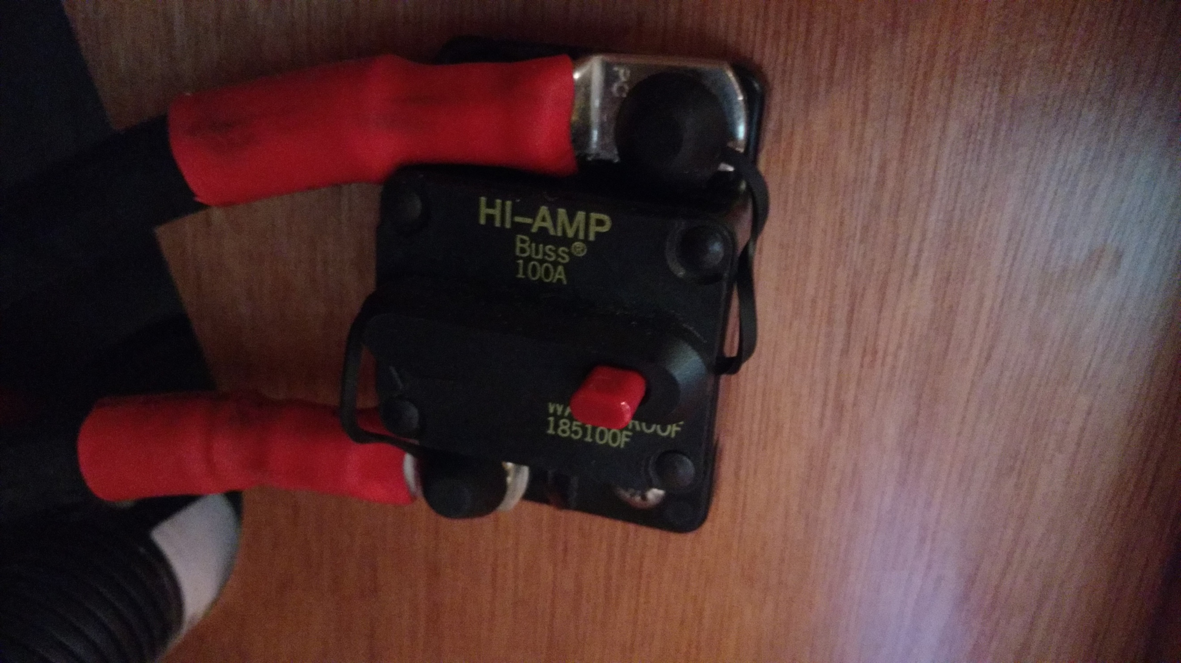The chain falls below into an enclosed chain well. It can be accessed from the forward compartment. The door pushes forwards.
* When raising out of the water take care not to let the anchor swing into the bow.
* Lash the anchor when it is on deck.
* Switch off winch power at the 12 volt switchboard.
* Anchor overload 100 amp circuit breaker is behind the cushions starboard side under the 12 volt electrical panel – see photo.